
CYPRUS INTERNATIONAL UNIVERSITY

MICROPROCESSORS
CMPE324 / EELE324
GROUP MEMBERS:
1. AUGUSTIN KABWE KALIMBA 22326035
2. DEFI MUKEBO KASONGO 22323612
3. MELIK KOÇHAN 22207971
Directed by:
Asst. Prof. Dr. FUAT UYGUROĞLU
Asst. Prof. Dr. Öykü AKAYDIN

FINAL TERM PROJECT

Department of Electrical-Electronic and computer Engineering
Nicosia, Turkish Republic of Northern Cyprus
2025/2026

- Introduction

This final report presents the complete design and implementation of a Hexadecimal Countdown Display system using an Arduino Uno microcontroller and a single-digit 7-segment display. The system continuously counts down from F (15) to 0 in hexadecimal, displaying each digit for one second before cycling back.

The project demonstrates practical skills in embedded systems design, including GPIO control, software delay implementation, and lookup-table-based segment encoding. The ATMega328P microcontroller on the Arduino Uno platform was selected for its widespread support and robust digital I/O capabilities.

- System Overview & Block Diagram

The system is organized into three functional modules:

- Power Supply Module: The Arduino Uno is powered via USB (5V). This voltage is used directly to drive the digital output pins.

- Microcontroller Module (ATMega328P): Handles all logic — iterating through the countdown sequence, looking up segment bitmasks, and writing output signals to GPIO pins.

- Display Module: A common-anode 7-segment display connected to digital pins 2–9 through 220 Ω current-limiting resistors.

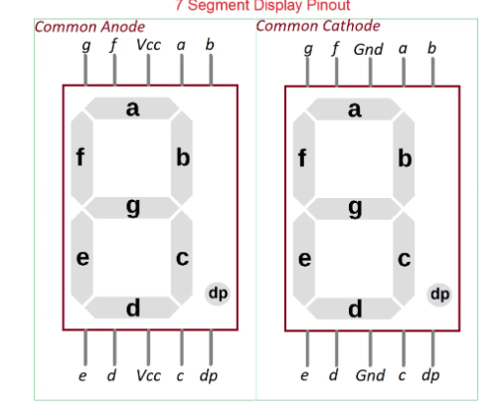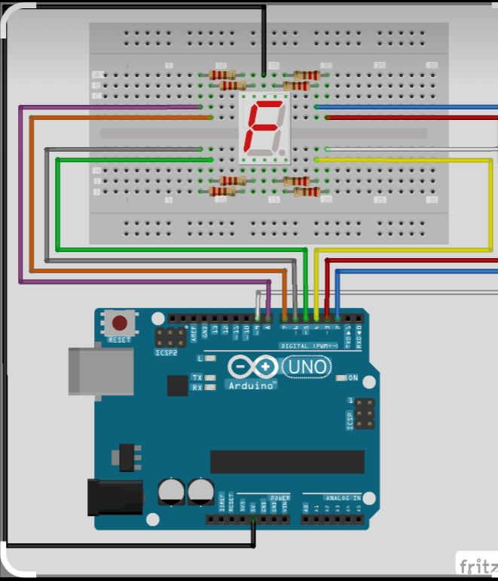

- Final Circuit Diagram & Hardware Implementation
The circuit was implemented on a breadboard. Each segment of the 7-segment display (a through g) is connected to an Arduino digital pin through a 220 Ω resistor. The decimal point (DP) pin is held permanently LOW (off). The common-anode pin of the display is connected to the Arduino's 5V supply.

Segment | Arduino Pin | Variable Name
a | Pin 7 | Aseg
b | Pin 6 | Bseg
c | Pin 4 | Cseg
d | Pin 3 | Dseg
e | Pin 2 | Eseg
f | Pin 8 | Fseg
g | Pin 9 | Gseg
DP (decimal point) | Pin 5 | DPseg (always LOW)

- Final pictures of the circuit

The following photographs show the assembled hardware during operation:

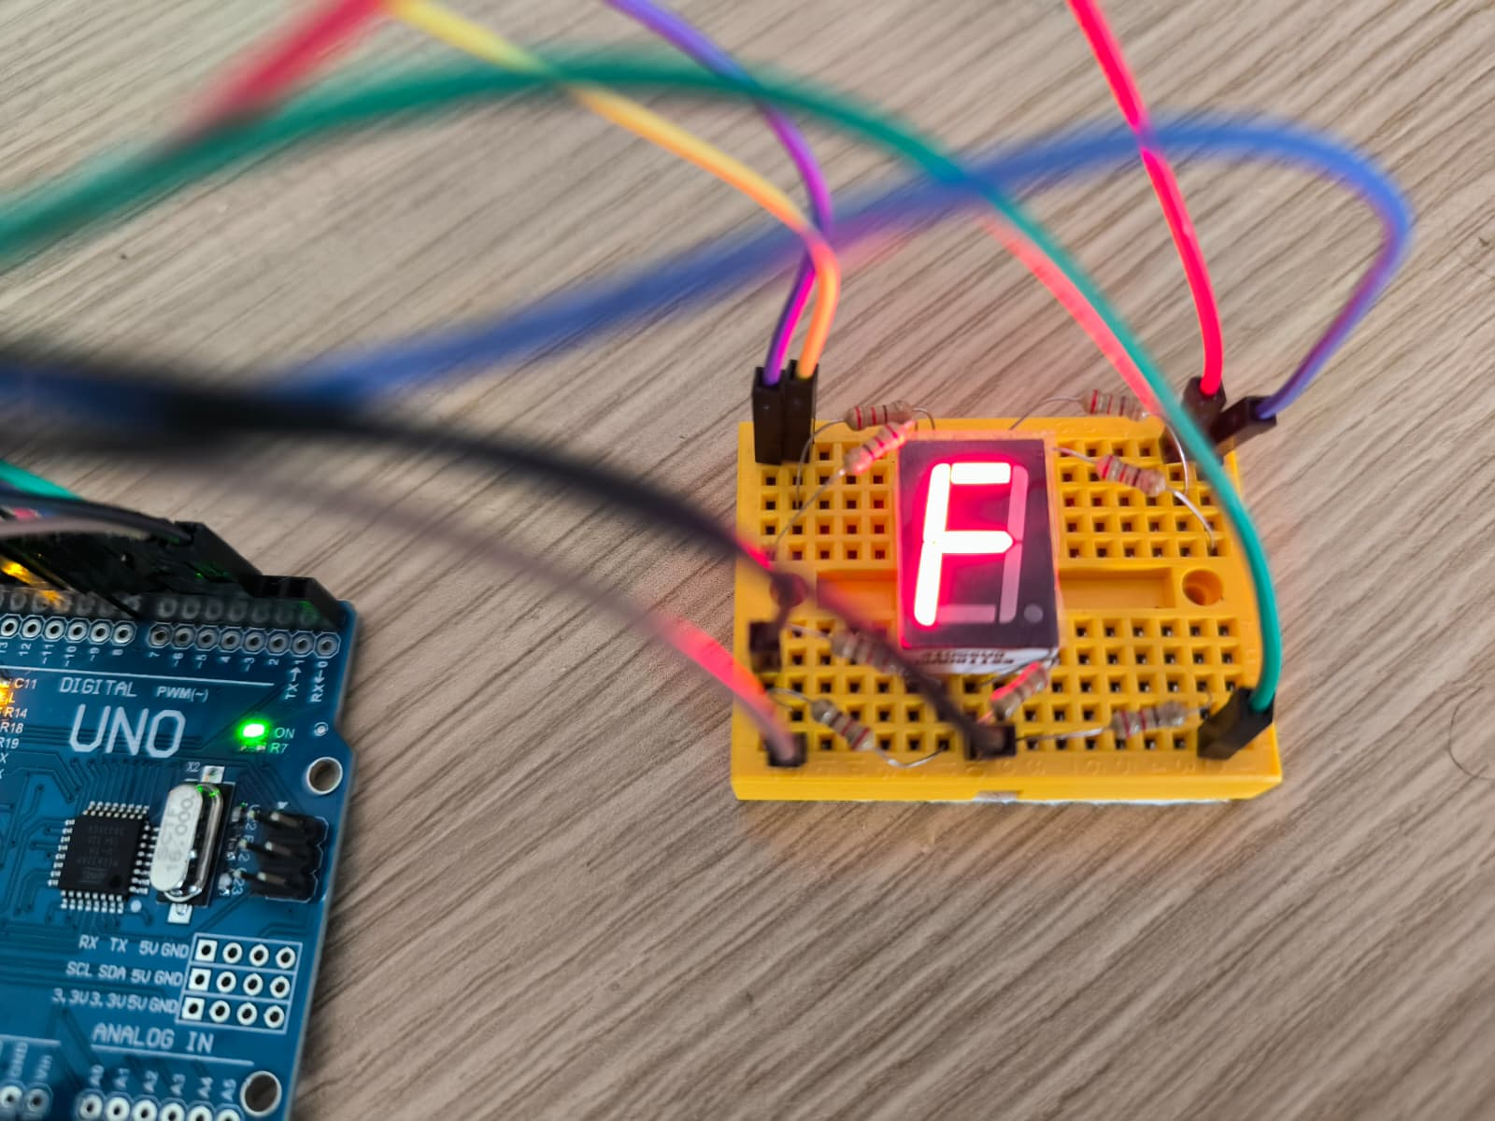
Figure 1 – Display showing the digit 'F' (start of countdown)

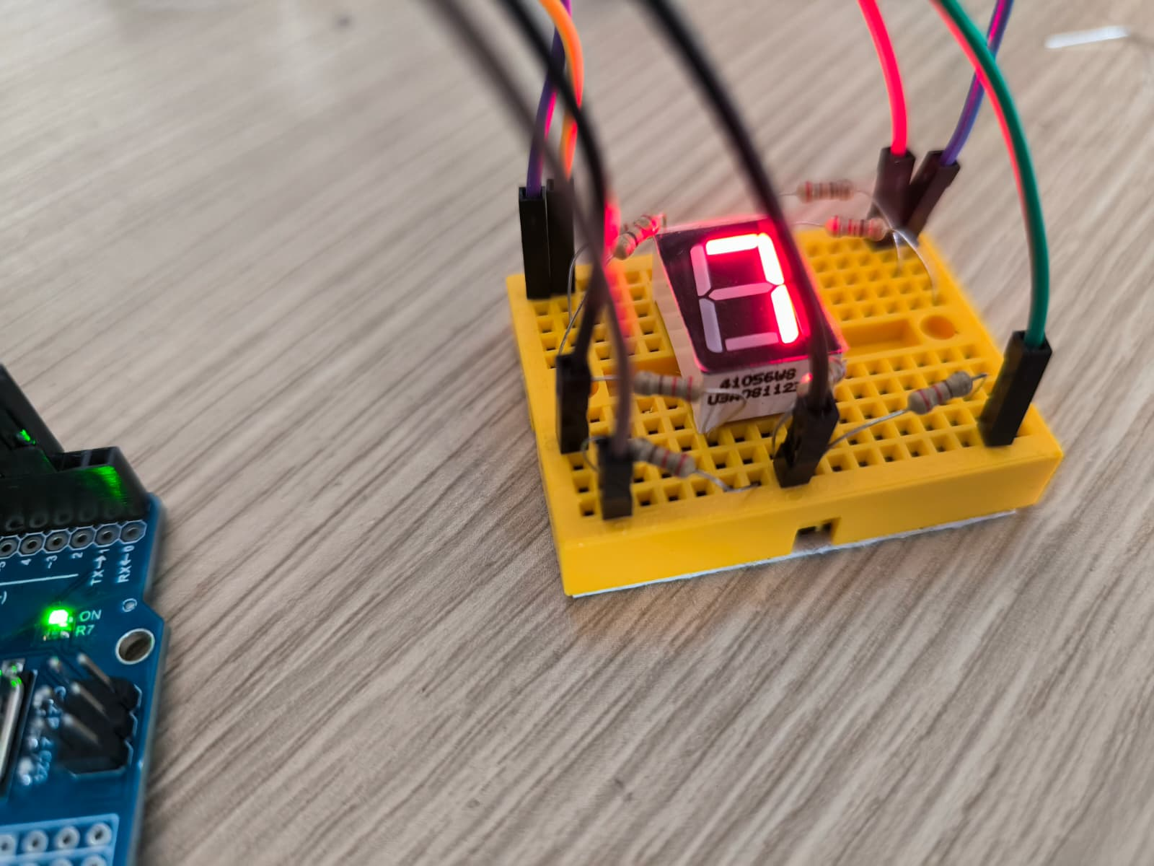
Figure 2 – Display showing digit '7' mid-countdown

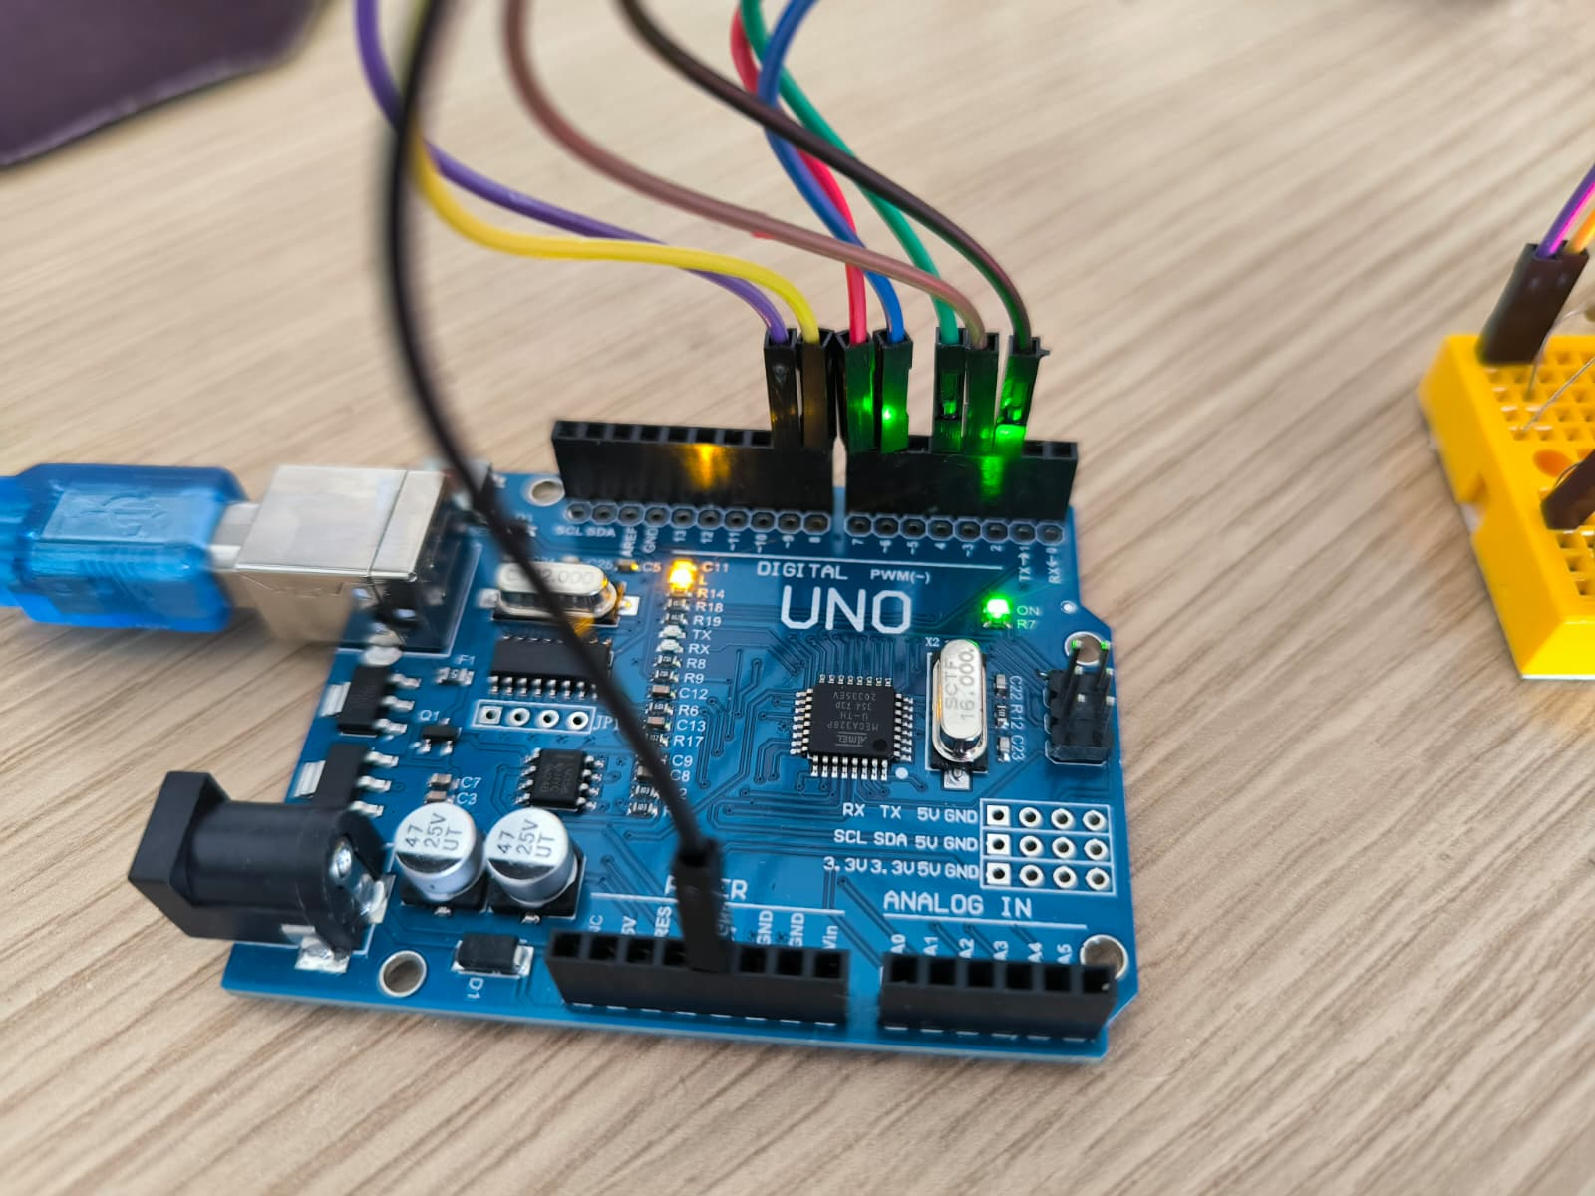
Figure 3 – Arduino Uno board with multi-color wiring to the breadboard

- Complete Program Code
// Segment pins
const int Eseg = 2; // E Segment on the 7-Segment Display is connected to DIGITAL Pin 2
const int Dseg = 3; // D Segment on the 7-Segment Display is connected to DIGITAL Pin 3
const int Cseg = 4; // C Segment on the 7-Segment Display is connected to DIGITAL Pin 4
const int DPseg = 5; // DP (Decimal Point) Segment on the 7-Segment Display is connected to DIGITAL Pin 5
const int Bseg = 6; // B Segment on the 7-Segment Display is connected to DIGITAL Pin 6
const int Aseg = 7; // A Segment on the 7-Segment Display is connected to DIGITAL Pin 7
const int Fseg = 8; // F Segment on the 7-Segment Display is connected to DIGITAL Pin 8
const int Gseg = 9; // G Segment on the 7-Segment Display is connected to DIGITAL Pin 9

// {A,B,C,D,E,F,G}
// Storing which segments will light up for a number or hexadecimal character in memory.
// Holds the pin states corresponding to hexadecimal numbers in A-G order.
byte hexDigits[16][7] = {

{1,1,1,1,1,1,0}, // 0
{0,1,1,0,0,0,0}, // 1
{1,1,0,1,1,0,1}, // 2
{1,1,1,1,0,0,1}, // 3
{0,1,1,0,0,1,1}, // 4
{1,0,1,1,0,1,1}, // 5
{1,0,1,1,1,1,1}, // 6
{1,1,1,0,0,0,0}, // 7
{1,1,1,1,1,1,1}, // 8
{1,1,1,1,0,1,1}, // 9
{1,1,1,0,1,1,1}, // A
{0,0,1,1,1,1,1}, // b
{1,0,0,1,1,1,0}, // C
{0,1,1,1,1,0,1}, // d
{1,0,0,1,1,1,1}, // E
{1,0,0,0,1,1,1} // F
};

// The purpose of this code is to configure the 7-segment display pins as outputs and turn off the decimal point.
// Function used to send/display whether the output from the pin to the segment is HIGH or LOW.
void setup() {

pinMode(Aseg, OUTPUT);
pinMode(Bseg, OUTPUT);
pinMode(Cseg, OUTPUT);
pinMode(Dseg, OUTPUT);
pinMode(Eseg, OUTPUT);
pinMode(Fseg, OUTPUT);
pinMode(Gseg, OUTPUT);
pinMode(DPseg, OUTPUT);

digitalWrite(DPseg, LOW); // Decimal point is turned off
}

// Sends the state to each segment and controls whether the segment is LOW(0) or HIGH(1).
void displayDigit(int num) {
digitalWrite(Aseg, !hexDigits[num][0]); // Sends 0 if 1, and 1 if 0 (Inverts the logic)
digitalWrite(Bseg, !hexDigits[num][1]);
digitalWrite(Cseg, !hexDigits[num][2]);
digitalWrite(Dseg, !hexDigits[num][3]);
digitalWrite(Eseg, !hexDigits[num][4]);
digitalWrite(Fseg, !hexDigits[num][5]);
digitalWrite(Gseg, !hexDigits[num][6]);
}

void loop() {

// F -> 0 countdown
for(int i = 15; i >= 0; i--) {

displayDigit(i);

delay(1000);}

- }Problems and solutions

Common-Anode Polarity

Challenge: Digits displayed incorrectly because the segments worked in reverse logic.
Solution: Since the display was common-anode, LOW signals were used to turn segments ON. Applying logical NOT (!) fixed the display output.

Segment Mapping

Challenge: Some digits appeared incorrect due to wrong segment connections.
Solution: Each pin was tested individually to identify the correct segment mapping, and the lookup table was updated.

Wiring Issues

Challenge: Incorrect wiring caused flickering and wrong patterns.
Solution: Color-coded wires and systematic checking of each connection improved accuracy and stability.

- CONCLUSION
This project successfully achieved all required objectives. A hexadecimal countdown display system was designed and implemented on the Arduino Uno platform, counting from F (15) down to 0 with a 1-second delay per digit, and looping continuously.

Key learning outcomes include: understanding common-anode vs. common-cathode display logic and polarity inversion, designing and using segment lookup tables for efficient multi-digit encoding, GPIO configuration and digital output control on the ATMega328P, and the trade-offs between software delay and timer-based timing methods.

The project also reinforced good engineering practices: systematic debugging (individual pin probing), clear code structure (named constants, helper functions), and hardware safety (current-limiting resistors). The final system is clean, stable, and fully meets the project specifications.

